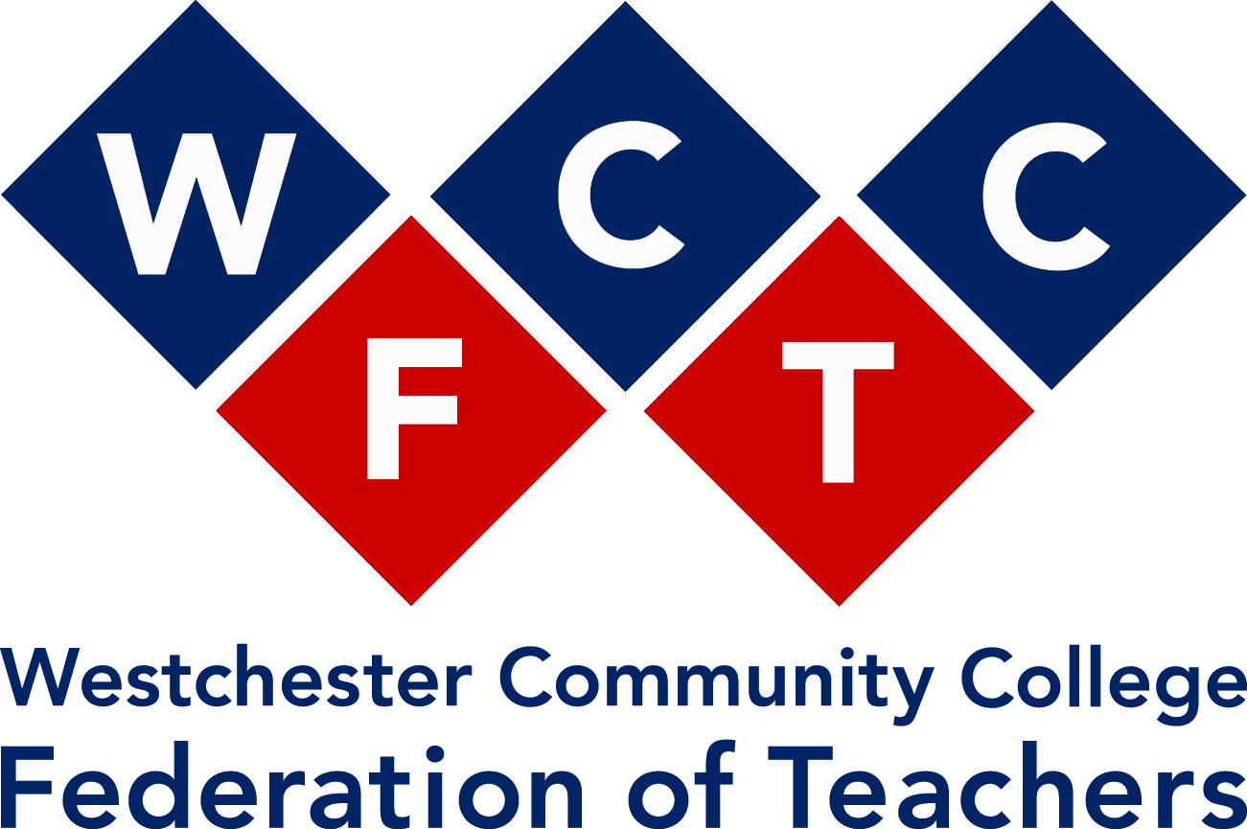

First Annual Student Cell Phone Photo Contest
The 1st Annual Photography Contest sponsored by the Westchester Community College Federation of Teachers is open to all WCC students. Both full-time and part-time students may enter.
Subject matter: Teachers, Librarians, or Counselors working
Cash prizes will be awarded:
First Place $75.00
Second Place $50
Third Place $25
The entry deadline is Thursday, November 21, 2013 (11:59 PM)
You may submit up to five cell phone images. Please submit your images by email to photocontest@sunywccft.org as digital files (in .jpg format, standard cell phone sizes – .jpg or .jpeg file extensions are the types most commonly found on a cellphones). All entrees must include:
- the photographer’s name, telephone number, and e-mail address
- the full name of the subject (the teacher, librarian, or counselor)
- the date and place where the photo was taken
- a sentence explaining the circumstances pictured in the photo (Example: Prof. Carver had just finished teaching a class about Shakespeare.)
- the following statement: “ By entering this contest, I understand that the WCCFT has one-time rights for publication of my contest submissions on its website, SUNYWCCFT.ORG.” Entries failing to include this statement will not be considered. The top three photos selected by the judges will be published on the WCCFT website, SUNYWCCFT.ORG. Some non-winning submissions may also be published on the WCCFT website.
You must ask all subjects for permission to take their pictures, explaining your purpose. The teachers, librarians, or counselors you photograph will later be contacted for permission to publish their images on the WCCFT website.

