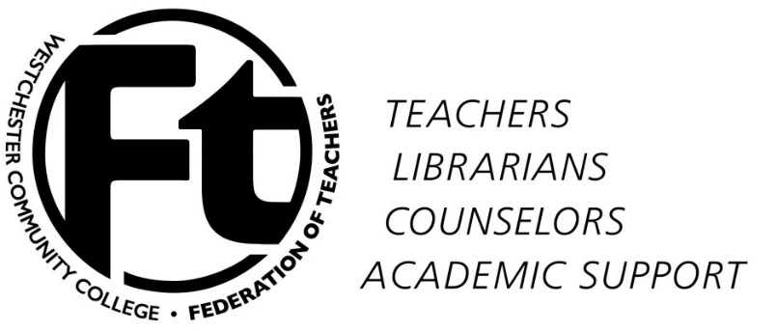

WCCFT Executive Committee
Meeting Summary
February 18, 2015

- Reports/announcements
  - Distance Learning Proposal – We have to agree with the changes the administration presented to us. MOTION: Accept changes made by the administration. APPROVED 11-0-0.
  - Mobilization work – The mobilization team started placing a message on the WCC facebook page and got some pushback from the Director of College-Community Relations. The team will start creating banners/ bumper stickers buttons so faculty may place them in their cars, offices, front office doors bulletin boards, etc.
  - “Meet the faculty” event for Dr. Miles – The event will be in the Student Event room on March 12, 2015 at 4:30pm. We will have presentations from faculty, songs, short intros and faculty greeting our New President.
  - Meeting with Assemblywoman Mayer and forum with Assembly members –The President had a conversation with Assemblywoman Mayer about the state having extra money to give to increase community college funding.
  - Register for Higher Ed conference- Registration is complete. The EB participants are ready to go.

- Election preparations – After a lengthy discussion the EB decided to maintain the process used for the last elections because there is not enough time at this point to implement recommendations for improvement. The Secretary will put out a call for volunteers for the Election Committee. During the first week in March he will send out the call for nominations. For future discussion: separating the RA election from the regular election to include a better description of the RA responsibilities and the member’s union involvement. We will also discuss using an online service to run the election.

- Constitutional changes – The Vice President tabled this item until the new EB is elected and we are able to discuss what needs to be changed. The discussion will be during our annual retreat time in May.

- Immediately upcoming activities

  - March Meeting – During our next general membership meeting scheduled for March 4, 2014 at 11am in the science building room 102, the President will explain the temporary agreement with the administration on promotions and not allowing credits on the B2 form. Document attached.
  - Negotiating Team Meeting – The team will be discussing nonmonetary issues.
  - NAWD Feb. 25 – WCCFT will not participate with this event.
  - Committee of 100 March 2-3 – Looking for volunteers to attend. More information to come.

- New business
  - Update Bulletin Board with spring 2015 Information – The secretary will provide the EB with new information for the spring 2015 semester.
  - Scholarship Committee – The committee met on February 17, 2015 to discuss the scholarship and how to proceed forward this semester. Applications will be available soon.

DL PROPOSAL: REVISED AS OF February 15, 2015

GRANDFATHER CLAUSE: Those faculty who have begun their 8 semesters protection as per the 2004-2008 agreement will be allowed to finish out the balance of the semesters to a total of 8. Faculty who are teaching online without the 8 semester rule will not be entitled to the above.

SCOPE:
- This agreement will apply to fully online courses and hybrids unless otherwise differentiated.
- The term “online” will refer to both types of instruction.
- Strictly for the purpose of fulltime teaching loads, hybrids will count as 50% online, 50% campus.
- This agreement applies to all semesters including summer.
- Faculty regular workload must include at least one face-to-face class.

COURSE CREATION AND ASSIGNMENTS
• These guidelines apply to fulltime and adjunct faculty.
• Each online course must be approved by the faculty member’s department, Associate Dean and the Academic Vice President.
• Course Ownership: The College acknowledges faculty members shall have sole ownership of any materials they create for their online courses. Faculty members shall take responsibility for obtaining copyright permission where needed to avoid copyright infringements.
• Assignments will be based on a faculty member’s request and seniority, and will follow processes outlined in the WCCFT. Exceptions listed below will prevent a faculty member from being bumped for the indicated time period.
• No faculty member will be required to teach an online course.
• A laptop/tablet will be provided to all fulltime faculty teaching an online course. All laptops/tablets will be kept current with respect to the current operating system and virus updates and to comply with the most current guidelines issued by the IT department. The College maintains ownership of the laptop/tablet and IT will maintain these computers. Adjunct faculty who are teaching online may loan out a laptop/tablet for use during the session(s) that they teach online courses. Although every effort will be made to have enough laptops/tablets available for each session, it is possible that at certain times that the demand may exceed the supply.

FACULTY:
- Recognizing that there are specific classes that the College may need developed in order to expand certificate and degree offerings for students, during the years 2015-2018, the Academic Vice President will set aside $10,000 per year to pay stipends equivalent to a one-credit hour to target the development of online/hybrid courses. The stipend may be paid as a 1-credit overload during the regular contracted semester, during winter intersession, or during summer. A Request For Proposals (RFP) will be issued on or before September 1 that stipulates the priority areas and criteria for application for use of these funds for the subsequent academic year (for example, an RFP will be issued on or before September 1, 2015 for use of funds in the 2015-2016 academic year for course development with the expectation that the course will be offered no later than Fall 2016). Please note that faculty may choose and are encouraged to develop online courses without this additional compensation.
• Faculty members teaching a fully online and/or hybrid course for the first time will be protected for the first and second time offered, not including summer. Therefore, during the protected semesters, no one will be allowed to bump this faculty member from this course.

CLASS SIZE
• For “first time fully online and/or hybrid faculty members”, the maximum class size will be 22 (or the campus cap, whichever is lower) for only that first semester of teaching a course that is new to the faculty member, regardless of how many online courses he/she has taught before.
- The maximum class size for a fully online course shall be 25 students or the campus planning norm, whichever is lower. (Note: Online science courses which require a lab on campus will be designated as hybrid but the course itself will be considered an online course in terms of class size.)
• The maximum class size for a hybrid course shall be 30 students or the campus planning norm (whichever is lower)
• In the first semester, the faculty member will be allowed to teach an online course with a minimum enrollment of 8 students. After that, the minimum enrollment will be 12 or less at the jurisdiction of the Associate Dean.
• Online courses cannot be overloaded.

COURSE ADMINISTRATION
- All services of the Online Education Office shall be available to support the faculty both with workshops and with one-on-one assistance.
- All College Policies, including those that stipulate the process of grade appeal, apply to online courses.
- The administration may not enter an online classroom without first notifying the faculty member in the same way that they would if they wanted to observe the faculty member in a classroom.
- Any technical reason for anyone to enter the online classroom should be preceded by notification to the faculty member.
- The college shall not sponsor or facilitate an online education course for which the instruction and content is derived from another institution (e.g. a Massive Open Online Course offered by another institution) and which would compete with a WCC course currently being taught and/or listed in the college.
- Course preview forms will be available to all students as soon as possible but no later than 7 days after the start of registration or when the course is assigned to a faculty member, whichever occurs last.
- If the administration decides to change the platform and faculty need to be re-trained, the administration will provide a stipend equivalent to 0.5 credits paid as an overage per faculty member for between 10 and 20 hours of training. The training must be available in person and online.

Agreement on Credentials Requirements for Reappointment and Promotion
By and Between
Westchester Community College
And
Westchester Community College Federation of Teachers

WHEREAS, there is widespread agreement among WCC faculty members and administrators that the existing credit eligibility requirements stated in the Collective Bargaining Agreement (Sections 3.2, 3.3, 3.4) are outdated, inequitable and not necessarily reflective of an applicant’s merit; and
WHEREAS, a number of faculty members have completed academic work at institutions that do not follow traditional United States academic credit models; and
WHEREAS, applications in the current round of personnel actions are due in a very short time;
NOW THEREFORE, the parties agree as follows:
- Upon execution of this Agreement, the following practices will be adhered to during the Spring Semester of 2015:
  - Applicants for reappointment and promotion shall not indicate the number of undergraduate and graduate credits received on their respective Transcript Verification “B2” Form. As such, the credit number section should be left blank (or deleted if already filled out).
  - Applicants are still required, however, to list terminal degrees received on their respective “B2” forms.
  - Any credits completed subsequent to receiving a terminal degree should be indicated in the “Professional Development” section of the applicant’s Personnel Information Form (“PIF”).
  - The number of credits will not be considered by the faculty or the administration as a requirement for holding the rank to which a faculty member is making application.

- The parties agree to begin negotiations as soon as is practicable but in any case during the Spring Semester of 2015 to replace the content of Sections 3.2, 3.3, and 3.4 of the CBA with language that does not include a number of semester hours of credit as a requirement to hold any faculty rank.

- If, for any reason, the parties do not agree to such a replacement for Sections 3.2, 3.3, and 3.4 of the CBA in time to take effect for personnel actions in semesters subsequent to Spring 2015, the practices described in (1) above for will be adhered to until an agreement is reached.

_____________________________ ______________________________
Association College

__________ __________
Date Date

