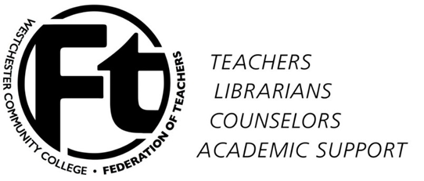
https://www.facebook.com/WCCFT
http://www.sunywccft.org

WCCFT Membership Meeting
January 28, 2015
Minutes

- Approval of minutes of December 3, 2014 meeting
The minutes were approved.
- Approval of agenda
The agenda was approved.
- Updates on contract negotiations – The President and Vice President meet with the new WCC President Dr. Belinda Miles. During the conversion the issue of waiting for the county’s CSEA to settle first was presented. WCCFT is planning to look into the situation further. In the meantime, Mike Wittenberg has agreed to put nonmonetary issues on table to see if we may resolve them while we wait for word on the other unions.

- Mobilization planning – The Mobilization Committee is working on a survey to see what faculty are willing to help with as we plan our next steps. Survey will be available during the first week in February.

- Negotiation on revising promotion credentials – Working on a proposed agreement in resolving issues with the promotion system. EB will discuss proposal during next EB meeting. More information to come.

- State and national developments – State Wide Issues – More Evaluations, longer road to getting tenure, closing failing schools, increasing chapter schools, and performance base funding.
National Wide Issues – Free Community Colleges 2.5 GPA and making progress towards graduation, the ranking of colleges, areas in which schools will be ranked graduation rates, employment opportunities.

- Member issues and questions – No member issues/questions.

- New Business – Scholarship Committee
Information will be sent out to the faculty for participation in this year’s Scholarship Committee.

- Adjournment
Meeting adjourned at 12:20pm.
Minutes submitted by Rafael Rodriguez – WCCFT Secretary

