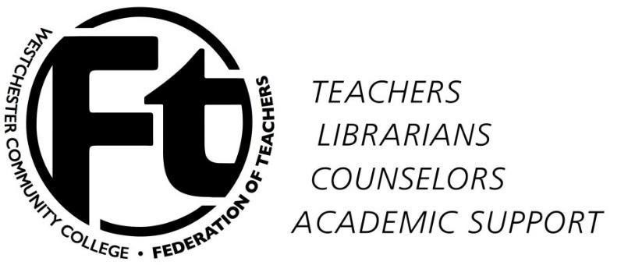

WCCFT Membership Meeting
December 2, 2015
Minutes

Approval of min utes/App roval of agenda – The minutes for November 4th general meeting were approved. The agenda for December 2nd general meeting was approved.

President’s report
NYSUT Community College Conference and Friedrichs Case(See attached for compete report) – The Community College Presidents met and talked about the fight in Albany for more FTE aid for Community Colleges. WCC was not represented by upper administration. During the meeting they also spoke about performance based funding in SUNY. The administrators felt it was inevitably coming but NYSUT staffers stated they will fight it in the legislature. State of Grievances – The grievance hearing about advisement against WCC will be heard in late December.
Town Hall and November Board of Trustees meetings – communication with Trustees – Several faculty spoke out during the meetings. There was definitely a good showing at the town meeting. The WCCFT President presented several email s the Dr. Miles sent him. He also provided some emails that he wrote to David Swope and Dr. Miles.

Report on status of negotiations – Judy Langer – WCCFT status has not changed we are in the process of figuring out where we go from here. After hearing Rob Astorino not accepting CSEA/ WCC agreement. CSEA filed an improper practice charge against the county and the school. They might have to start over with the county present at negotiations. They have a meeting with the county on December
14th. WCCFT might be headed in the same direction. We will find out more soon.

Call for nominations – delegates to NYSUT Representative Assembly April 8-9,
2016 – We will continue to accept nominations until December 9 th. Please let
faculty members know. We are looking for at least three more delegates.

Discussion of WCCFT Strategy – comments from members – Some of the ideas that faculty mentioned, vote of no confidence, sending updates through personal emails on a regular schedule, continue having a newsletter, and start a letter writing campaign.

Member issues and questions – N/A

New Business – No new business

Adjournment – Meeting Adjourned at 12:35PM. Minutes submitted by Rafael Rodriguez

