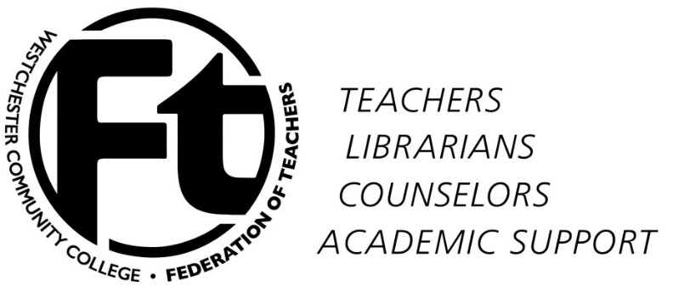

WCCFT Executive Committee
Unofficial Agenda/Minutes
October 7, 2015

Present: Mel Bienenfeld, Rafael Rodriguez, Don Shernoff, Rowan Lindley, Joanna Peters, Don Weigand

Approval of minutes/approval of agenda – No minutes were taken; we did not have a quorum.

Summing up of recent developments

Button-wearing
Senate meeting
Inauguration
More “New Era” developments
CSEA vote
Contract situation

Relating contract struggle to struggle against the “New Era” – how are they related and how does that effect mobilization?

Presenting info at today’s membership meeting

CSEA MOA results
Senate meeting and Mel’s statement (attached)
“New Era” developments
Administration intransigence in negotiations – how to present this?

Possible mobilization tactics (for the Board and for the membership)

Refusal to serve on search committees?
Produce alternate buttons for those who don’t like the size?
Attend BOT meetings with buttons? Signs?
Use of media (VN, JN, Channel 12)
Rally at the Open House – Nov. 17
Other campus events before 11/17?
Other ideas??

New Business

Adjournment

