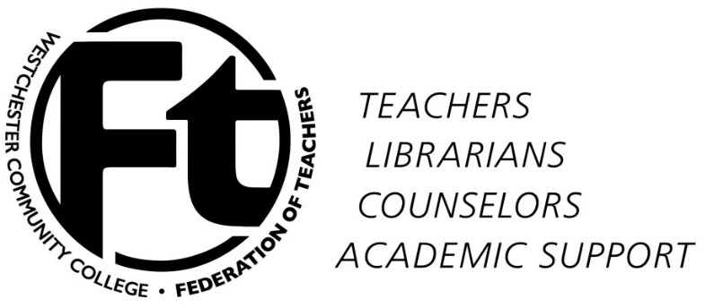

WCCFT Executive Committee
MINUTES
November 18, 2015

Present: Mel Bienenfeld, Judy Langer, Rafael Rodriguez, Don Shernoff, Kathleen Collins, Joanna Peters, Gwen Roundtree-Evans, Rosemarie Serrano-Sager, Don Weigand, Scott Zaluda, Alex Zemcov

Approval of minutes/approval of agenda
The minutes were approved 10-0-0. The agenda was approval with slight changes.

Duties of Board members – Mel
EB members participating in sponsored WCCFT events was discussed and we understand that some EB members are torn in fully having support for the activities we have against the administration i.e. buttons, signs etc. MOTION: EB does not consider any negative consequences of Gwen’s refusing to hold signs in front of Dr. Miles. 9-0-3. We discussed that EB members need to check their WCCFT emails on a regular bases.
Contract Meeting – About 13 faculty members participated in the meeting held to discuss the contract and what rights do faculty have at WCC. We are planning to continue this in the future.

Brief comments on NYSUT conference
Towanda’s participation – Her participation at the conference was very positive and she represented WCCFT well. She provided great insight at the workshops. We are trying to involve her in more WCCFT committees.
Higher Ed Lobby Day (and in-district visits) – See attached NYSUT CC Report
Performance-Based Funding – See attached NYSUT CC Report
Unemployment Insurance for Adjuncts – See attached NYSUT CC Report
Addresses of Fee Payers – See attached NYSUT CC Report
Union work through other structures (e. g. Faculty Senate)
Other?

Faculty Development Fund Report – We pro rating the total amount of $34,961.15 from the full-time applications to $29,650.68. As far as the adjunct applications we did not have to pro rate their request. The total was $4,562.75.

Report of Negotiating Team – We are still waiting for either the county or the college to decide who WCCFT is going to negotiate with. Our team has schedule meeting during next few weeks to stay ready.

Strategy discussion – We will discuss with the faculty what other strategies they are willing or able to do during this period of waiting to finalize our contract. We are looking for their ideas because the word we got back was that some are not comfortable in doing what we have plan recently. The general meeting will be December 2nd.

New business – WCCFT is planning more adjunct events for the future.

Adjournment – Meeting was adjourned at 12:50pm.

Minutes are submitted Rafael Rodriguez
NYSUT CC Conference Report
Dinner on Friday:
Report on the Freidrichs case (regarding a union’s right to collect agency fees). Our side’s case (produced by the AFT/NEA and other bodies) seems strong with many influential amicis. But of course the consequences of Freidrichs being upheld, or any of the many other cases the right wing has in the pipeline are very serious for the future of unions. It is very important that a Democratic president is elected, as several Supreme Court justices will probably be appointed in the next presidential term.
Saturday:
Sessions 1 & 2 Negotiations 101 and 201:
There was much helpful information about how to choose our negotiating team, how to create and prepare our proposals, whether or not to have ground rules, how to keep members abreast of progress, what to look for during negotiations. One interesting point was that the presenters did not think there was a need for ground rules and that there should be no confidentiality agreement.
I felt that the kind of negotiating that they were discussing was different from ours (currently) because they were describing actual content being discussed whereas I feel that that does not happen during our negotiations were vast amounts of time are taken up by MW pontificating; we present proposals and get nothing (with any progress) back. The presenters suggested that we ask if the other side has the authority to make decisions because the Taylor law says they must.
Session 3:
Community College Structure: Who Has the Power?
The idea of this presentation was that unions shod use other college structure to strengthen our voice and influence decision making. So we should talk to each our members and find out how they might best advance the Union message through college structures such as the Senate, Board of Trustees meetings, meetings on promotions and tenure, and other college committees. This seems like an overwhelming task, but perhaps even if only steps are taken in this direction it could be very helpful.
ED 39 Meeting:
We learned about upcoming events. We were encouraged to mobilize student to come with us to Higher Education Lobby Day on Feb 25th. NYSUT has found that the legislators listen better to students than to us. Some useful tips were: get the students to organize a petition to take with them, ask NYSUT for help with buses, get the social science professors involved, have students visit the legislators in their home districts when they return.
We should nominate someone to go to the Leadership Institute (details should have been mailed to our office).
Erie Community College had stressful and contentious negotiations for six years and ended up with a good contract. There may be light at the end of the tunnel!

Trending Issues in Higher Education:

Information about:
The renewal of the Higher Education Act and what changes are wanted by the House, the Senate and the President.
Performance based funding. SUNY is going along with it but NYSUT maintains that it is not a given and we should continue to campaign against it while performance is not measured in any way correctly.
“Free” community college which it turns out may not be such a good idea for New York as our costs are higher than average across the country, and we would be dependent on the Federal government and the state (with its poor track record) to make up our funding. We would not be able to raise tuition as we can now when our county sponsor and the state fail to provide their share.

Report on 2015 NYSUT Community College Conference
Mel Bienenfeld

Presidents’ Luncheon: I was one of a few union presidents who was an “orphan” – our college president was not there. On the agenda was mutual work on lobbying for more NY State funding. SUNY Central Admin, the CC presidents, and the union presidents have all agreed to push for a 5-year funding plan in which base aid is increased $250 per FTE student per year. Also, the college presidents’ group wants to work with the unions to get busloads of students to Higher Ed Lobby Day. I said that I would ask our president to participate, and asked if she would be also pushed on the admin side. I was told yes, the CC presidents’ group would push it.

NYSUT made sure to put Performance-Based Funding on the agenda. See Rowan’s report on the ED 39 meeting which accurately summarized what happened. Apparently the CC presidents are part of something called a “Voluntary Accountability Framework” in which they want to tweak the meaning of “performance” but still accept that colleges would be funded this way.

Chris Black, NYSUT’s Higher Ed legislative guy, prepared a report for me on legislation about unemployment insurance payments for adjuncts, which I will share with our adjuncts.

Community Engagement Workshop: Like many of the workshops, it was skewed towards dealing with Friedrichs and the other Supreme Court challenges to unions. For this the “community” to be engaged is our fee payers. (Kathleen did a great job of describing all our adjunct outreach efforts.) The presenter (a NYSUT LRS) said that we are entitled to the fee payers’ home addresses.
Amanda had thought that was not the case, so she will look into it. We need to get an accurate, complete, easily updatable database of our bargaining unit.

Nikki Richardson then did a section on the community beyond the campus, her great report which we basically heard in Tarrytown last summer.

Union Message Workshop: Also skewed to Friedrichs. One important idea: unions save people from being “at will employees” who are vulnerable to any whim of the employer.

For other sessions, see Rowan’s report.

