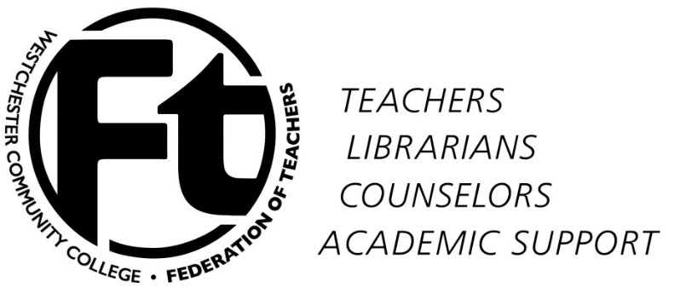

WCCFT Executive Committee
Minutes
September 17, 2015

Present: Mel Bienenfeld, Judy Langer, Don Shernoff, Rafael Rodriguez, Rowan Lindley, Joanna Peters, Don Weigand, Alex Zemcov

Approval of minutes/approval of agenda
Minutes were approved for August 29, 2015 8-0-0.
Agenda for September 17, 2015 was approved with slight changes 8-0-0.

- Reports/announcements

  - Results of Membership meetings 9/9 and 9/10 followed by discussion – The general meeting and the Health report meeting was a success. We were able to answer questions that the membership had.
  - Convocation action – We still undecided on what we going to do about convocation and any mobilization.
  - New CSEA vote – The CSEA has a new proposal from the WCC administration they will vote on it in the next week.
  - Contract situation after 9/16 negotiations – We are trying to get the negotiations completed before the October 2, 2015 date.

- Upcoming activities

  - NYSUT speaker on Friedrichs case – at October or November meeting? – Still not decided.
  - Community College Conference November 13-15: Board members going? Send other members as well? We have about 8 EB members interested.
  - Higher Ed Policy Council September 25-26 (Presidents only) - Tabled

- New business – No new business.

Adjournment – Meeting adjourned 4:55pm

Minutes submitted by Rafael Rodriguez

