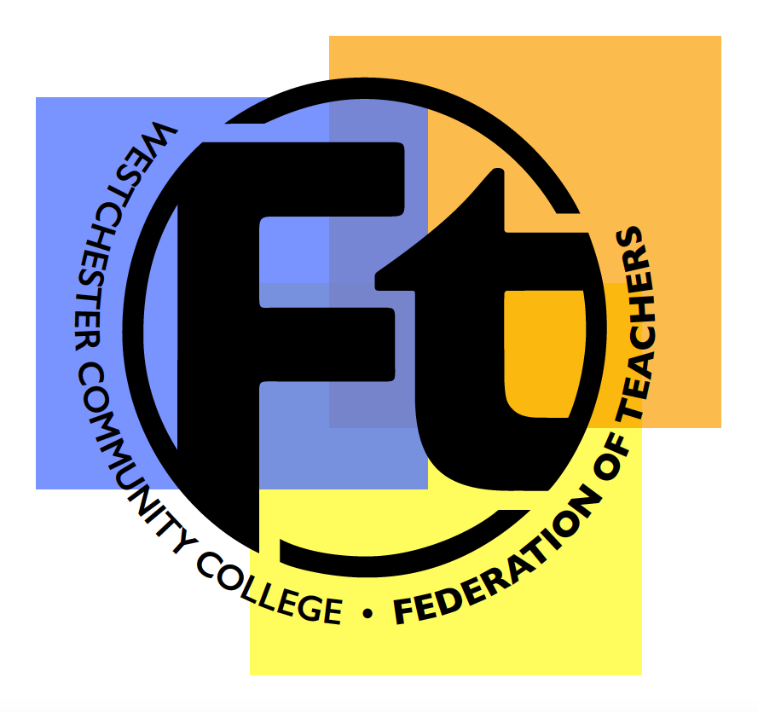

ELIGIBILITY:

You must be employed as a full-time faculty member at Westchester Community College at the time of application. You must be a member of the WCCFT at the time of the activity. This application form is for activities completed between September 1, 2022 and August 31 , 2023.

APPLICATION INSTRUCTIONS:

You may apply for reimbursement for expenses incurred for a conference, workshop, class, professional research or similar professional activity. Please include:
- documentation in the form of receipts (credit card bills are not acceptable)
- confirmation of the activity, such as certificates, conference announcement, conference brochure that includes the sponsoring organization, the location, and the dates.
- supporting documentation for any mileage (e.g., Google maps)
For professional activities, the union will reimburse for expenses integral and necessary to complete the project, for example, travel (with justification of the need), lab use, archival access, photocopying. All reimbursements are only for expenses pertaining to the activity itself. We do not reimburse for membership fees for professional organizations or subscriptions to journals.

Your award will depend on the amount of funds available and the total number of applications received from full-time faculty for this period. The total fund will be divided amongst all the applicants with a maximum of $2,000 to be paid to any one member. You may receive up to 100% of the cost of the activity from all sources of funding.

All receipts and evidence for each activity must be submitted with this application, otherwise it will not be considered. Please organize them so they are easy to read.

SUBMISSION DEADLINE:

Applications for WCCFT Full-Time Faculty Development Funds must be received by:
Saturday, September 30, 2023. Late applications will not be accepted.

Please return completed applications as a pdf to gwenrewccft@gmail.com

Name:
WCC Office Location: | Office Tel Ext:
Department:

Please itemize expenses and attach receipts on the next page.

- Meals: Please note the current maximum amount funded per day is $60
- Mileage: Please include supporting documentation (e.g. Google Maps). Your claim must be based on the reimbursement of 62.5 cents per mile for September 1, 2022 – January 30, 2023, and as of January 31, 2023, 65.5 cents per mile.

Did you receive funding for these activities from any other sources? If so, please specify the amount and source using the following table.

Amount Received: | Source:
$
$
$
Total Received:

Subtract Total Received from Total Expenses (listed on the following page) to determine Total Request.

Total Request: $ ________________ (Maximum $2,000)

Signature: | Date:

 | Activity 1 | Activity 2 | Activity 3 | Activity 4
Description
Location
Date(s)
Expenses
Air/Rail
Car Rental
Lodging
Registration
Mileage
Other (specify)
Meals ($60 per day max)
Day 1
Day 2
Day 3
Day 4
Day 5
Day 6
Day 7
Total Expenses | $ | $ | $ | $

